cutters are great tools for slicing through bulky material quickly and easily. They are also versatile because the retractable blades allow you to modify the blade length depending on the thickness of the material being cut.
In spite of their convenience, box cutters pose a hazard, since the blades are very sharp, and we don’t generally think of these as requiring special precautions!
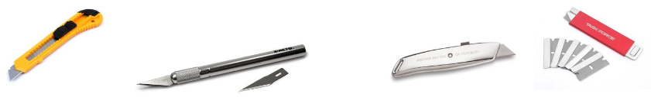
BOX CUTTER SAFETY TIPS:
To prevent injuries while using one of the many types of box cutters, consider the following:
Keep the Blade Sharp - Sharp blades will cut. Dull blades will tug and pull, which is more likely to cause your hand to slip and cut your fingers. Replace when dull, and never use a broken blade!
Shorten the Blade - Most box cutters allow you to choose the length of the blade. Keep the blade as short as possible.
Keep it Covered - Retract the blade as soon as possible. When you put your box cutter away, make sure that it's protected with a cover. If the blade is not available, you can’t get cut!
Angle It Away From Your Body - There is no reason to cut directly towards you. If you cut at an angle, your hand will move away from your body if it slips.
Cut Deliberately - Apply a consistent, firm (but not excessive) pressure while performing the cut. Use your arm to move the blade in a deliberate motion so that slipping becomes unlikely. Concentrate on the material to be cut and watch the blade at all times.
Consider Cutting Half Way - Rather than cut all the way through the material being cut, consider cutting only halfway through, flipping the item around, and cutting the other half.
Keep Your Thumb Away - It's tempting to put your thumb right by the blade when you cut since you get better balance, but don't put your thumb anywhere near the blade.
Put Your Other Hand Away - You don't need to put your hand right by the blade when you cut. Put your hand far enough away and back to avoid cutting it.
Wear Gloves - If you can, it's always a good idea to wear gloves when you use a box cutter. This will prevent any small nicks and cuts from minor errors.
Changing blades - Take care when changing dull or damaged blades. Dispose of blades in a safe manner. Put them in a puncture resistant container.

